1. tambahkan date, color, dan file picker pada bagian berikut (dapat dilihat pada gambar)

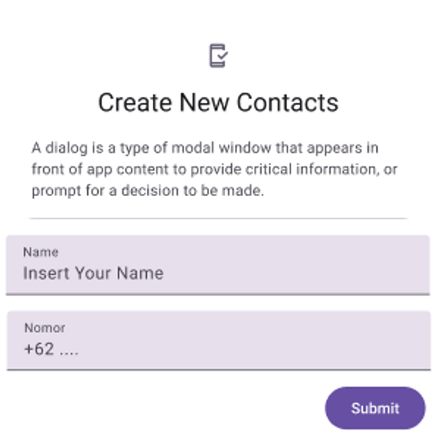

* Contacts.dart

import 'dart:io';

import 'package:flutter/material.dart';

import 'package:flutter_platform_widget/FlutterForm/ListContactsModel.dart';

import 'package:flutter_colorpicker/flutter_colorpicker.dart';

import 'package:file_picker/file_picker.dart';

import 'package:intl/intl.dart';

class Contacts extends StatefulWidget {

const Contacts({Key? key}) : super(key: key);

@override

State<Contacts> createState() => _Contacts();

}

class _Contacts extends State<Contacts> {

final _formKey = GlobalKey<FormState>();

ListContactsModel? contactsModel;

final TextEditingController namaController = TextEditingController();

final TextEditingController nomorController = TextEditingController();

DateTime _selectedDate = DateTime.now();

Color pickerColor = const Color(0xffEADDFF);

Color currentColor = Colors.blue;

String? _fileName;

String _filePath = "";

Future<void> _selectDate(BuildContext context) async {

final DateTime? picked = await showDatePicker(

context: context,

initialDate: _selectedDate,

firstDate: DateTime(1900),

lastDate: DateTime(2100),

);

if (picked != null && picked != _selectedDate) {

setState(() {

_selectedDate = picked;

});

}

}

void changeColor(Color color) {

setState(() => pickerColor = color);

}

void onColorChanged(Color color) {

setState(() => currentColor = color);

}

void _openFilePicker() async {

try {

FilePickerResult? result = await FilePicker.platform.pickFiles(

type: FileType.any,

allowMultiple: false,

);

if (result != null) {

setState(() {

_fileName = result.files.single.name;

_filePath = result.files.first.path!;

});

}

} catch (e) {

print("Error while picking the file: " + e.toString());

}

}

@override

Widget build(BuildContext context) {

return Theme(

data: ThemeData(brightness: Brightness.light),

child: Scaffold(

appBar: AppBar(

backgroundColor: const Color(0xff6750A4),

title: const Text("Contacts"),

),

body: ListView(

children: <Widget>[

Container(

alignment: Alignment.center,

padding: const EdgeInsets.only(top: 81),

child: const Icon(Icons.contact_page),

),

Container(

alignment: Alignment.center,

padding: const EdgeInsets.only(top: 10),

child: const Text(

"Create New Contacts",

style: TextStyle(

fontFamily: 'Roboto-Regular',

fontSize: 24,

color: Color(0xff1C1B1F)),

),

),

Container(

alignment: Alignment.center,

padding: const EdgeInsets.only(top: 10),

margin: const EdgeInsets.only(left: 40, right: 40),

child: const Text(

"A dialog is a type of modal window that appears in front of app content to provide critical information, or prompt for a decision to be made.",

maxLines: 3,

overflow: TextOverflow.ellipsis,

textAlign: TextAlign.justify,

style: TextStyle(

fontFamily: 'Roboto-Regular',

fontSize: 14,

color: Color(0xff49454F),

),

),

),

SizedBox(

height: 35.0,

child: Center(

child: Container(

padding: const EdgeInsets.only(top: 30),

margin:

const EdgeInsetsDirectional.only(start: 40.0, end: 40.0),

height: 1.0,

color: Colors.black12,

),

),

),

Form(

key: _formKey,

child: Column(

children: [

Container(

padding: const EdgeInsets.only(top: 8),

margin: const EdgeInsets.only(left: 16.0, right: 16.0),

decoration: const BoxDecoration(

color: Color(0xffE7E0EC),

),

child: TextFormField(

controller: namaController,

validator: (value) {

List list = value!.split(' ');

if (value.isEmpty) {

return 'Nama harus di isi';

} else if (list.length < 2) {

return 'Nama harus terdiri dari minimal 2 kata';

} else if (!RegExp(

r'^[A-Z][a-zA-Z]*(?: [A-Z][a-zA-Z]*)*$')

.hasMatch(value)) {

return 'Nama harus dimulai dengan huruf kapital';

} else if (!RegExp(r'^[a-zA-Z ]+$').hasMatch(value)) {

return 'Nama tidak boleh mengandung angka atau karakter khusus';

}

return null;

},

decoration: const InputDecoration(

floatingLabelBehavior: FloatingLabelBehavior.always,

contentPadding: EdgeInsets.only(left: 16),

hintText: "Insert Your Name",

hintStyle: TextStyle(

fontFamily: 'Roboto-Regular',

fontSize: 16,

),

labelText: "Name",

labelStyle: TextStyle(

fontFamily: 'Roboto-Regular',

fontSize: 12,

),

),

),

),

Container(

padding: const EdgeInsets.only(top: 8),

margin: const EdgeInsets.only(

top: 15.0, left: 16.0, right: 16.0),

decoration: const BoxDecoration(

color: Color(0xffE7E0EC),

),

child: TextFormField(

// keyboardType: TextInputType.phone,

controller: nomorController,

validator: (value) {

if (value!.isEmpty) {

return 'Nomor harus di isi';

} else if (!RegExp(r'^[0-9]+$').hasMatch(value)) {

return 'Nomor telepon harus terdiri dari angka saja';

} else if (value.length < 8) {

return 'Nomor telepon minimal 8 digit';

} else if (value.length > 15) {

return 'Nomor telepon maksimal 15 digit';

} else if (value[0] != '0') {

return 'Nomor telepon harus dimulai dengan angka 0';

}

return null;

},

decoration: const InputDecoration(

floatingLabelBehavior: FloatingLabelBehavior.always,

contentPadding: EdgeInsets.only(left: 16),

hintText: "+62 ....",

hintStyle: TextStyle(

fontFamily: 'Roboto-Regular',

fontSize: 16,

),

labelText: "Nomor",

labelStyle: TextStyle(

fontFamily: 'Roboto-Regular',

fontSize: 12,

),

),

),

),

],

),

),

ListTile(

contentPadding:

const EdgeInsets.only(top: 10, left: 16, right: 16),

leading: const Text(

'Date',

style: TextStyle(

fontFamily: 'Roboto-Regular',

fontSize: 16,

color: Color(0xff1C1B1F),

fontWeight: FontWeight.bold,

),

),

trailing: TextButton(

onPressed: () => _selectDate(context),

child: const Text(

'Select',

style: TextStyle(

fontFamily: 'Roboto-Regular',

fontSize: 16,

fontWeight: FontWeight.bold,

),

),

),

),

Container(

width: double.infinity,

padding: const EdgeInsets.only(left: 16),

child: Text(

'${_selectedDate.day}-${_selectedDate.month}-${_selectedDate.year}',

style: const TextStyle(

fontFamily: 'Roboto-Regular',

fontSize: 14,

color: Color(0xff49454F),

),

),

),

const SizedBox(height: 20.0),

Container(

width: double.infinity,

padding: const EdgeInsets.only(left: 16),

child: const Text(

'Color',

style: TextStyle(

fontFamily: 'Roboto-Regular',

fontSize: 16,

color: Color(0xff1C1B1F),

fontWeight: FontWeight.bold),

),

),

const SizedBox(height: 10.0),

Container(

width: double.infinity,

height: 50.0,

margin: const EdgeInsets.only(left: 16, right: 16),

decoration: BoxDecoration(

color: currentColor,

shape: BoxShape.rectangle,

borderRadius: BorderRadius.circular(5),

),

),

const SizedBox(height: 20.0),

Container(

margin: const EdgeInsets.only(left: 130, right: 130),

child: RaisedButton(

color: currentColor,

shape: RoundedRectangleBorder(

borderRadius: BorderRadius.circular(5),

),

onPressed: () {

showDialog(

context: context,

builder: (BuildContext context) {

return AlertDialog(

title: const Text('Pick a color'),

content: SingleChildScrollView(

child: ColorPicker(

pickerColor: pickerColor,

onColorChanged: changeColor,

showLabel: true,

pickerAreaHeightPercent: 0.8,

),

),

actions: [

FlatButton(

child: const Text('Cancel'),

onPressed: () {

Navigator.of(context).pop();

},

),

FlatButton(

child: const Text('Apply'),

onPressed: () {

onColorChanged(pickerColor);

Navigator.of(context).pop();

},

),

],

);

},

);

},

child: const Text(

'Pick Color',

style: TextStyle(

fontFamily: 'Roboto-Regular',

fontSize: 16,

color: Colors.white,

),

),

),

),

const SizedBox(height: 20),

Container(

width: double.infinity,

padding: const EdgeInsets.only(left: 16),

child: const Text(

"Pick Files",

style: TextStyle(

fontFamily: 'Roboto-Regular',

fontSize: 16,

fontWeight: FontWeight.bold,

color: Color(0xff1C1B1F),

),

),

),

Container(

padding: const EdgeInsets.only(left: 16, top: 10),

child: Text(

_fileName ?? "No file selected.",

),

),

_filePath != "" ? Image.file(File(_filePath)) : Container(),

Container(

margin: const EdgeInsets.only(left: 130, right: 130, top: 10),

child: RaisedButton(

onPressed: _openFilePicker,

color: Colors.blue,

shape: RoundedRectangleBorder(

borderRadius: BorderRadius.circular(5),

),

child: const Text(

"Pick and Open File",

style: TextStyle(

fontFamily: 'Roboto-Regular',

fontSize: 16,

color: Colors.white,

),

),

),

),

Container(

alignment: Alignment.centerRight,

padding: const EdgeInsets.only(top: 15, right: 15),

child: SizedBox(

width: 94,

height: 40,

child: ElevatedButton(

style: TextButton.styleFrom(

backgroundColor: const Color(0xff6750A4),

shape: RoundedRectangleBorder(

borderRadius: BorderRadius.circular(20.0))),

onPressed: () {

if (_formKey.currentState!.validate()) {

if (contactsModel.runtimeType != Null) {

ListContactsModel items = contacts.firstWhere(

(e) => e.no_telp == contactsModel!.no_telp);

items.nama = namaController.text;

items.no_telp = nomorController.text;

items.date = _selectedDate;

items.color = pickerColor;

items.image = _filePath;

namaController.text = '';

nomorController.text = '';

_fileName = null;

_filePath = "";

currentColor = Colors.blue;

contactsModel = null;

setState(() {});

for (var item in contacts) {

print("${item.nama} | ${item.no_telp}");

}

} else {

contacts.add(

ListContactsModel(

nama: namaController.text,

no_telp: nomorController.text,

date: _selectedDate,

color: pickerColor,

image: _filePath,

),

);

for (var item in contacts) {

print("${item.nama} | ${item.no_telp}");

}

namaController.text = '';

nomorController.text = '';

_fileName = null;

_filePath = "";

currentColor = Colors.blue;

setState(() {});

}

}

},

child: const Text(

"Submit",

style: TextStyle(

fontFamily: 'Roboto-Regular',

fontSize: 14,

),

),

),

),

),

Container(

alignment: Alignment.center,

padding: const EdgeInsets.only(top: 59),

child: const Text(

"List Contacts",

style: TextStyle(

// fontWeight: FontWeight.bold,

fontFamily: 'Roboto-Regular',

fontSize: 24,

color: Color(0xff1C1B1F),

),

),

),

Padding(

padding: const EdgeInsets.only(top: 10, bottom: 10),

child: ListView.separated(

shrinkWrap: true,

physics: const NeverScrollableScrollPhysics(),

itemBuilder: (ctx, i) {

return ListTile(

leading: Container(

clipBehavior: Clip.hardEdge,

decoration: BoxDecoration(

color: contacts[i].color.runtimeType != Null

? contacts[i].color

: const Color(0xffEADDFF),

shape: BoxShape.circle,

),

width: 50,

height: 50,

child: contacts[i].image.runtimeType != Null &&

contacts[i].image != ""

? Image.file(

File(contacts[i].image!),

fit: BoxFit.cover,

)

: Center(

child: Text(

contacts[i].nama[0],

style: const TextStyle(

fontFamily: 'Roboto-Regular',

fontSize: 16,

color: Color(0xff21005D),

),

),

),

),

title: Text(

contacts[i].nama,

style: const TextStyle(

fontFamily: 'Roboto-Regular',

fontSize: 16,

color: Color(0xff1C1B1F),

),

),

subtitle: Column(

crossAxisAlignment: CrossAxisAlignment.start,

children: [

Text(

contacts[i].no_telp,

style: const TextStyle(

fontFamily: 'Roboto-Regular',

fontSize: 14,

color: Color(0xff49454F),

),

),

Text(DateFormat('dd-MM-yyyy')

.format(contacts[i].date)),

],

),

trailing: Wrap(

spacing: 23,

children: [

InkWell(

onTap: () {

setState(() {

contactsModel = contacts[i];

namaController.text = contacts[i].nama;

nomorController.text = contacts[i].no_telp;

if (contacts[i].color.runtimeType != Null) {

currentColor = contacts[i].color!;

} else {

currentColor = Colors.blue;

}

if (contacts[i].image.runtimeType != Null &&

contacts[i].image != "") {

_fileName = contacts[i].image!.split('/')[6];

_filePath = contacts[i].image!;

} else {

_fileName = null;

_filePath = "";

}

});

},

child: const Icon(

Icons.edit_outlined,

color: Color(0xff1C1B1F),

),

),

InkWell(

onTap: () {

contacts.removeAt(i);

setState(() {});

},

child: const Icon(

Icons.delete_outline,

color: Color(0xff1C1B1F),

),

),

],

),

);

},

separatorBuilder: (ctx, i) {

return const Divider();

},

itemCount: contacts.length),

),

],

),

),

);

}

}

Output :

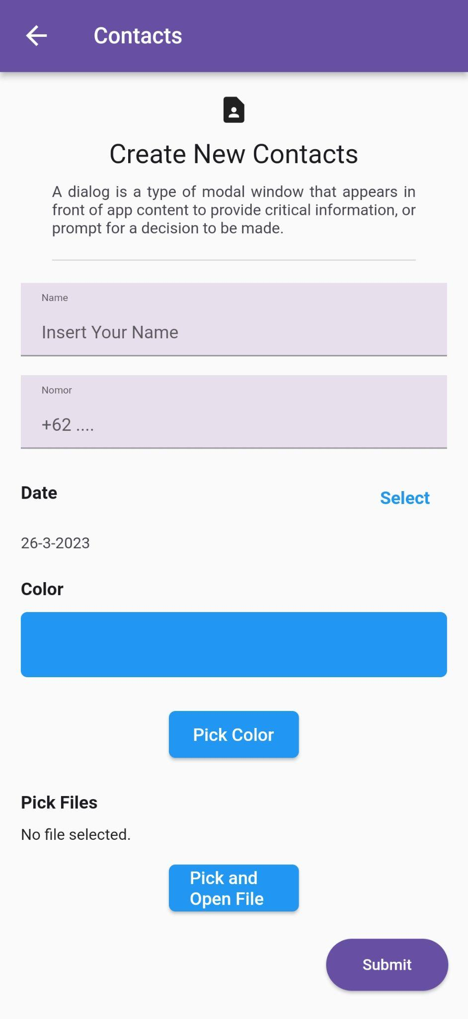

1. ketika button submit di tekan akan memasukkan data name, nomor, date, color dan file ke dalam variabel yang telah kalian buat.

Code Button Submit :

Container(

alignment: Alignment.centerRight,

padding: const EdgeInsets.only(top: 15, right: 15),

child: SizedBox(

width: 94,

height: 40,

child: ElevatedButton(

style: TextButton.styleFrom(

backgroundColor: const Color(0xff6750A4),

shape: RoundedRectangleBorder(

borderRadius: BorderRadius.circular(20.0))),

onPressed: () {

if (_formKey.currentState!.validate()) {

if (contactsModel.runtimeType != Null) {

ListContactsModel items = contacts.firstWhere(

(e) => e.no_telp == contactsModel!.no_telp);

items.nama = namaController.text;

items.no_telp = nomorController.text;

items.date = _selectedDate;

items.color = pickerColor;

items.image = _filePath;

namaController.text = '';

nomorController.text = '';

_fileName = null;

_filePath = "";

currentColor = Colors.blue;

contactsModel = null;

setState(() {});

for (var item in contacts) {

print("${item.nama} | ${item.no_telp}");

}

} else {

contacts.add(

ListContactsModel(

nama: namaController.text,

no_telp: nomorController.text,

date: _selectedDate,

color: pickerColor,

image: _filePath,

),

);

for (var item in contacts) {

print("${item.nama} | ${item.no_telp}");

}

namaController.text = '';

nomorController.text = '';

_fileName = null;

_filePath = "";

currentColor = Colors.blue;

setState(() {});

}

}

},

child: const Text(

"Submit",

style: TextStyle(

fontFamily: 'Roboto-Regular',

fontSize: 14,

),

),

),

),

),

Output :

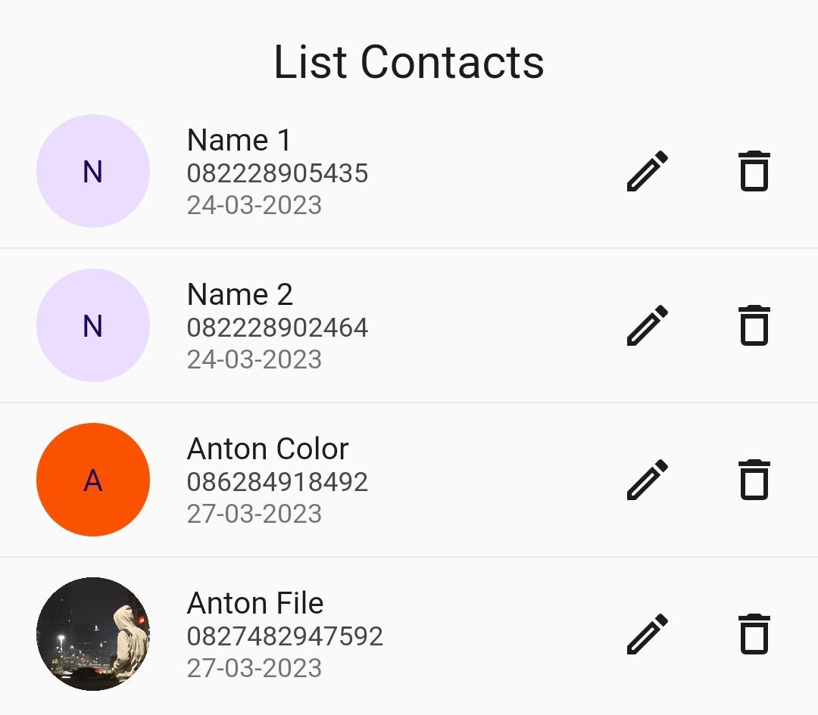

Penjelasan :

Data telah berhasil di submit dengan memasukkan date, color, dan file. Pada Contacts Anton Color, saya menginputkan date 27-03-2023 dan color warna orange yang digunakan sebagai background color dari profile contacts image. Pada Contacts Anton File, saya menginputkan date 27-03-2023 dan file gambar yang digunakan sebagai profile contacts image.

1. untuk membuktikan bahwa data telah berhasil untuk masuk, kalian cukup melakukan logDev pada console. ilustrasi dapat dilihat pada gambar di bawah

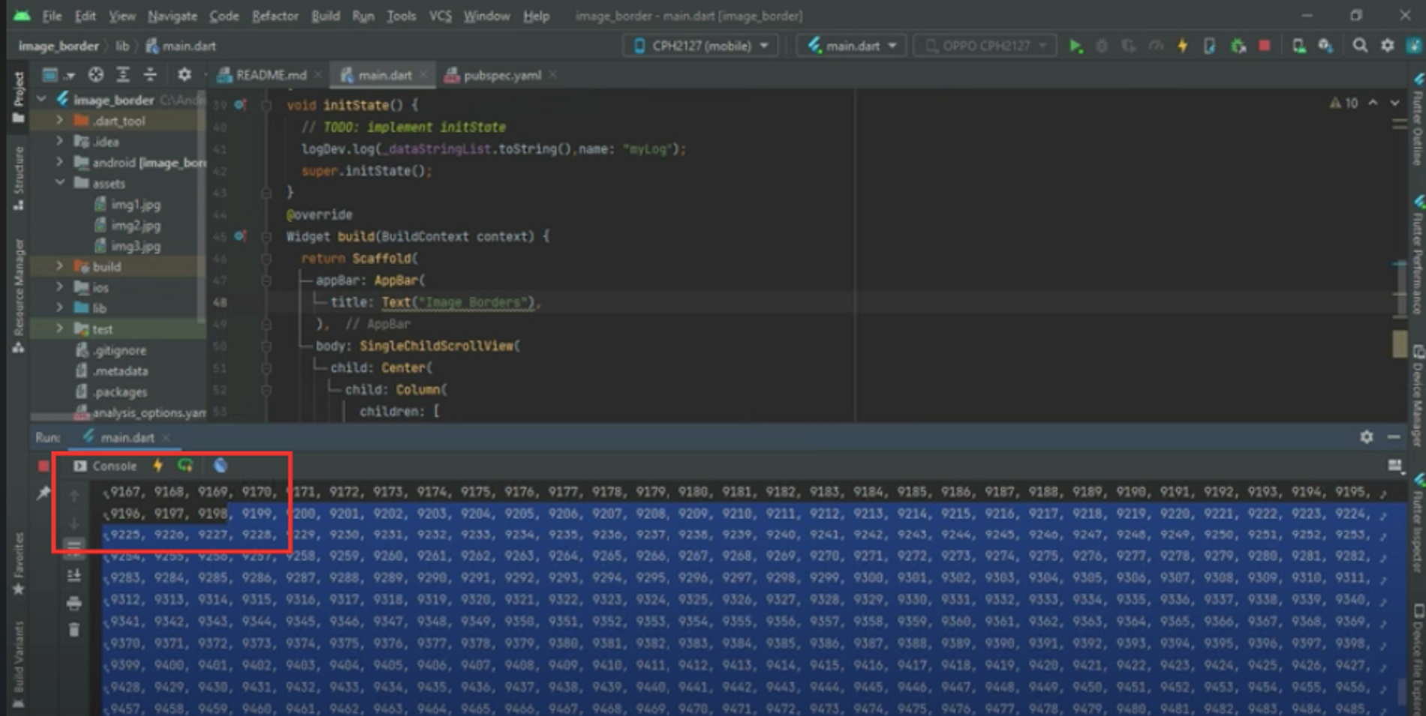

Output :

